Munir Abbasi 20K-0244 Raza Ali Abidi 20K-1061 Mustafa Zahid 20K-1045

Testing suite for blood management system

TEST Cases

|  |  |
| --- | --- |
| Name | User Login ID=1 |
| Requirement | Requirement id=2 |
| Precondition | User must be on “Home Page” of the Website, the account must exist. |
| Steps | 1. Click on “User Login” button on the Top Bar 2. Enter Username 3. Enter Password 4. Click “Submit” |
| Expected Results | Login Successful if matching entries found in database. Then new “User Home” opens.  Login Unsuccessful if no entries found. No response from the website. |

|  |  |
| --- | --- |
| Name | User Contribute Money ID=2 |
| Requirement | Requirement id =9 |
| Precondition | User has Signed in. User must have an account. |
| Steps | 1. Click on the “Contribute Money” button on top bar 2. Enter Amount 3. Enter valid details on Receipt Details 4. Click on “Process to pay “ button. |
| Expected Results | Validation Message in the URL bar. |

|  |  |  |  |  |  |
| --- | --- | --- | --- | --- | --- |
| Conditions | | | |  |  |
| Valid Full name | T | F | F | F | F |
| valid Email ID | T | F | F | F | T |
| valid Mobile Number | T | F | F | T | F |
| valid Amount | T | F | T | F | F |
| Actions | | | | | |
| Successful donation | T |  |  |  |  |
| Unsuccessful donation |  | T | T | T | T |

Domain Analysis for contribute.amount

|  |  |
| --- | --- |
| Name | Donate Blood ID=3 |
| Requirement | Requirement id=11 |
| Precondition | User must be on “Home Page” of the Website.  User must have an Account . |
| Steps | 1. Click on “Donate Blood” button on Top bar. 2. Enter valid Donor ID. 3. Enter conformation message. 4. Enter valid Hospital ID. 5. Click on “Save” button. |
| Expected Results | A Successfully Updated message will be displayed on page.  If data entered is in valid, invalid message will be displayed on URL bar. |

|  |  |
| --- | --- |
| Name | Search Blood ID=4 |
| Requirement | Requirement id = 12 |
| Precondition | User must be on logged in his account. User must have an Account . |
| Steps | 1. Click on “Find Blood” button on Top bar. 2. Select Blood Group 3. Select a valid city. 4. Click on “Submit” button. |
| Expected Results | A page will open which will display all the details about the blood you want to find, it will include details of:   * Donor List * Blood Bank List * Hospital List |

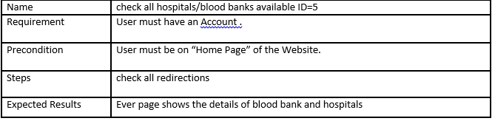

Hospital must exist.

Requirement id=13

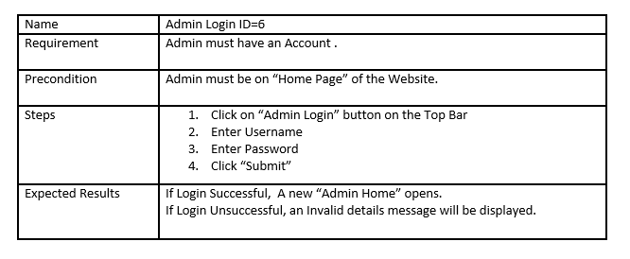

Admin account must exist.

Requirement id=3

|  |  |
| --- | --- |
| Name | Manage Stock ID=7 |
| Requirement | Requirement id= 5. |
| Precondition | Admin must be on “Home Page” of the Website. Admin must have an Account . |
| Steps | 1. Click on the “Manage Stock” button on top bar. 2. Select Blood group. 3. Select increase or decrease. 4. Enter units to add/remove. 5. Click Save. |
| Expected Results | An increase or decrease will be shown in the Table |

|  |  |
| --- | --- |
| Name | Add New Donor ID=8 |
| Requirement | Requirement id=14. |
| Precondition | Admin must be on “Home Page” of the Website. Admin must have an Account . |
| Steps | 1. Click on “Add new donor” Button on Top bar. 2. Enter all Valid details 3. Click “Save” button. |
| Expected Results | If data entered is valid, a Successfully Updated message will be displayed on Screen.  If weight enter is below 50 kg the donor cannot be added (TRIGGER)  If data is in valid An invalid message will be displayed in URL bar. |

|  |  |
| --- | --- |
| Name | Delete List of Donors ID=9 |
| Requirement | Requirement id=4 |
| Precondition | Admin must be on “Home Page” of the Website. Admin must have an Account . |
| Steps | 1. Click on “Delete List of Donors” button on top bar. 2. Click on Delete button on detail of donors you want to perform these actions. |
| Expected Results | When click on “edit” a new page is displayed which ask admin to edit details  When click on “delete” the data of donor will be deleted. |

|  |  |
| --- | --- |
| Name | User signup ID=10 |
| Requirement | Requirement id =1 |
| Precondition | User must be on “Home Page” of the Website. User needs to have an email, phone number to register successfully. |
| Steps | 1. User will click on the sign up button. 2. User will enter the first name. 3. User will enter the last name. 4. User will add a user name. 5. User will enter password. 6. User will enter address. 7. User will enter a contact number. |
| Expected Results | When click on “edit” a new page is displayed which ask admin to edit details  When click on “delete” the data of donor will be deleted. |

|  |  |
| --- | --- |
| Name | Check request for blood ID=11 |
| Requirement | Requirement id = 7 |
| Precondition | Admin must be on request for blood page. |
| Steps | 1. Admin sees the table. 2. Admin Accepts the request for blood. 3. Admin redirects to Request completed. 4. Admin must be able to see recent transaction. |
| Expected Results | When click on “edit” a new page is displayed which ask admin to edit details  When click on “delete” the data of donor will be deleted. |

|  |  |
| --- | --- |
| Name | user request for blood ID=12 |
| Requirement | Requirement id =12 |
| Precondition | user must be on request for blood page. User can login. |
| Steps | 1. User goes to request blood. 2. Enters valid data to make a request. 3. Clicks on submit. |
| Expected Results | When click on “edit” a new page is displayed which ask admin to edit details  When click on “delete” the data of donor will be deleted. |

|  |  |
| --- | --- |
| Name | Admin can enter new hospital ID=13 |
| Requirement | Requirement id=15 |
| Precondition | Admin must be logged In. User can login. |
| Steps | 1. Admin goes to add new hospital tab. 2. Admin enters valid data to add a hospital. 3. Admin submits it. |
| Expected Results | New hospital added that can be viewed by the user. |

# TESTING SUITES

|  |  |
| --- | --- |
| Test Suite Name | Manage Donor Information TS=1 |
| Test Suite usage | Once a donor is registered, the admin can delete their data. |
| Test cases Included | 1. Test case 10. 2. Test case 1 3. Test case 6. 4. Test case 3. 5. Test case 9. |
| Test results | Successful deleting of the data of the donor. |

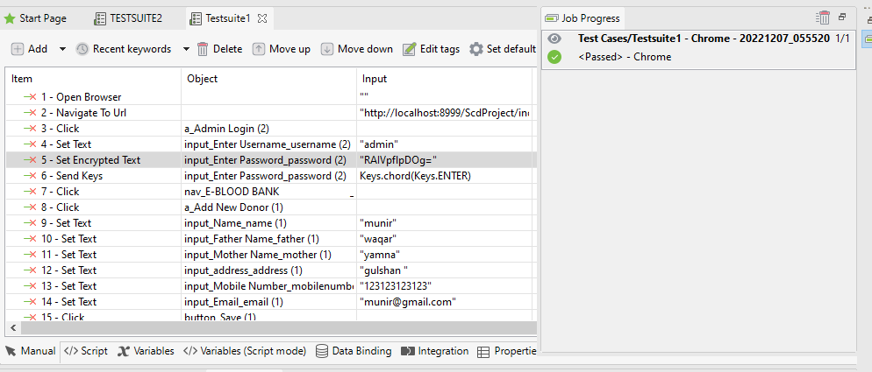

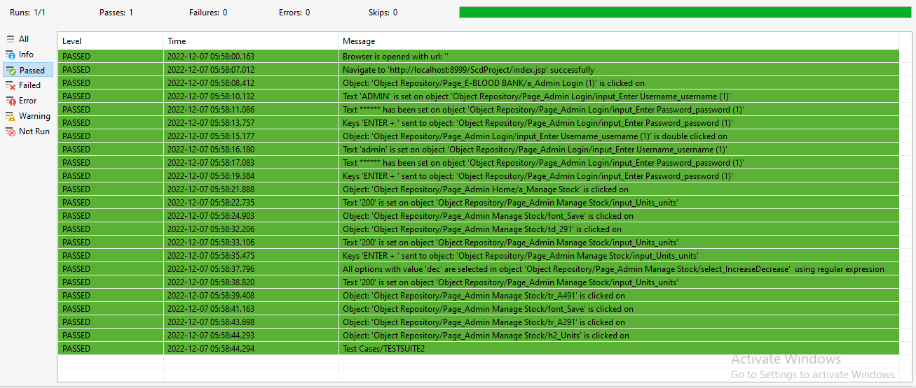

|  |  |
| --- | --- |
| Test Suite Name | Manage Hospital Blood stock TS=2 |
| Test Suite usage | Once an admin logs in, the admin can manipulate the stock. |
| Test cases Included | 1. Test case 10. 2. Test case 6. 3. Test case 7. |
| Test results | Admin successfully increases and then decreases the stock. |

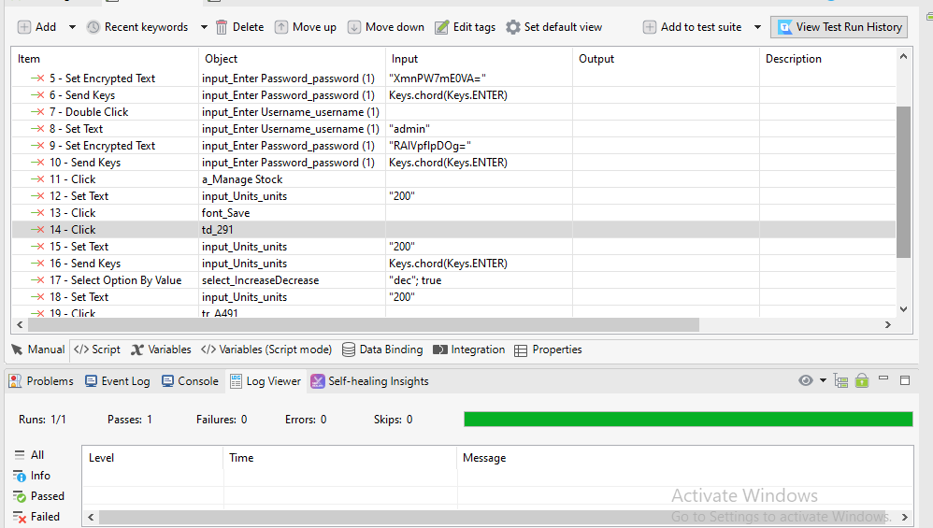

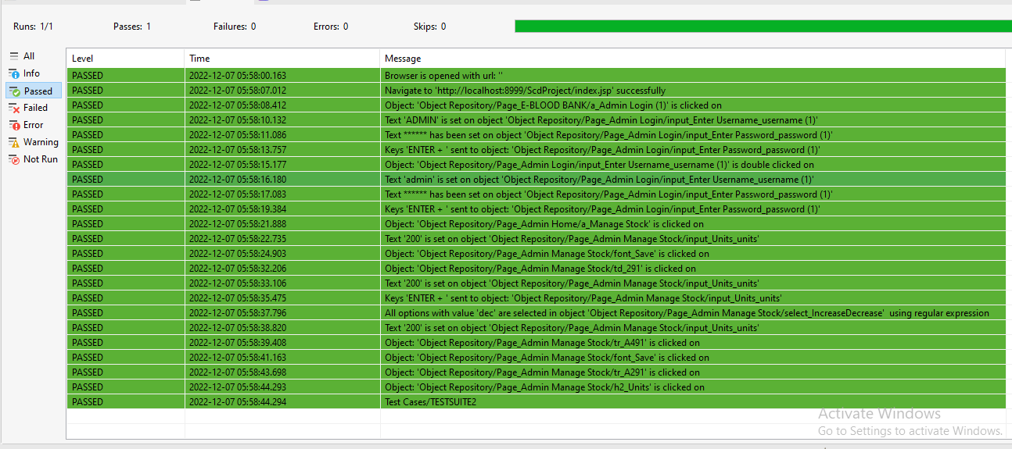

|  |  |
| --- | --- |
| Test Suite Name | User request blood and admin approves. TS=3 |
| Test Suite usage | Once an admin logs in, the admin can accept or delete the user requests. For completed requests, he must view them in the request completed tab. |
| Test cases Included | 1. Test case 1. 2. User logs out. 3. Test case 6. 4. Test case 11. |
| Test results | The request is shown in competed tab of admin. |

‘

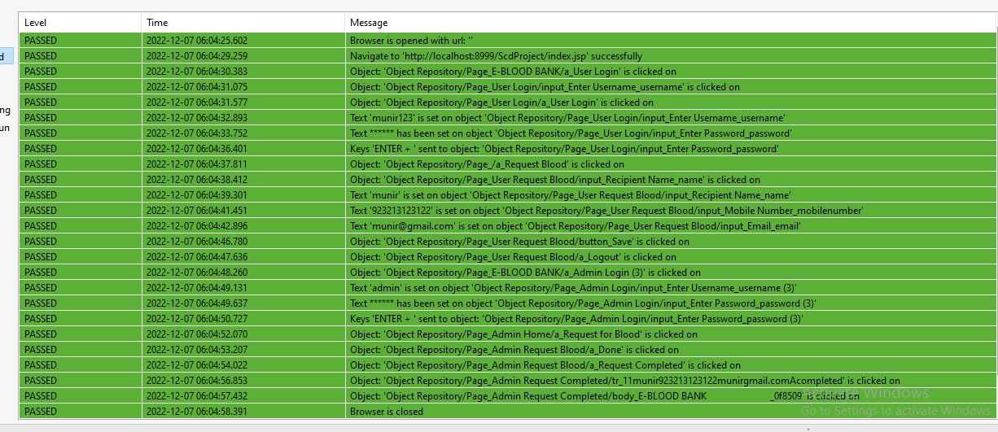

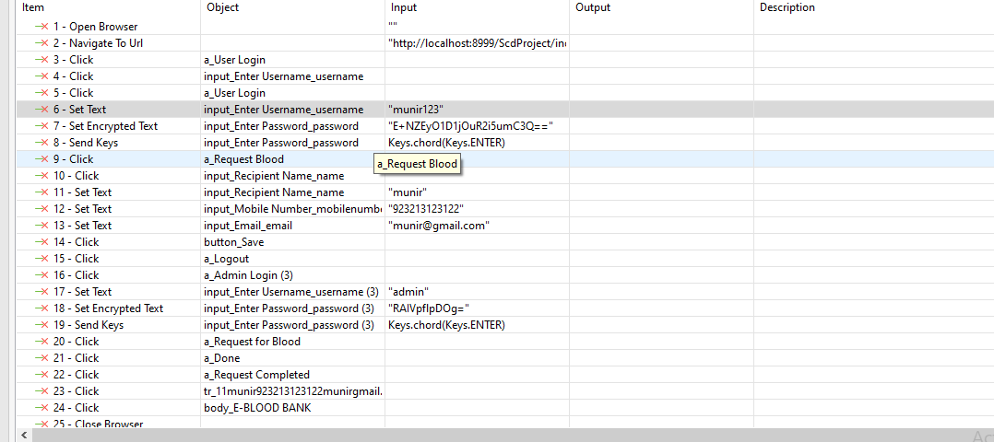

|  |  |
| --- | --- |
| Test Suite Name | User makes a money donation TS=4 |
| Test Suite usage | Once an admin logs in, the admin can accept or delete the user requests. For completed requests, he must view them in the request completed tab. |
| Test cases Included | 1. Test case 1. 2. Test case 2. |
| Test results | User donation saved in database. |

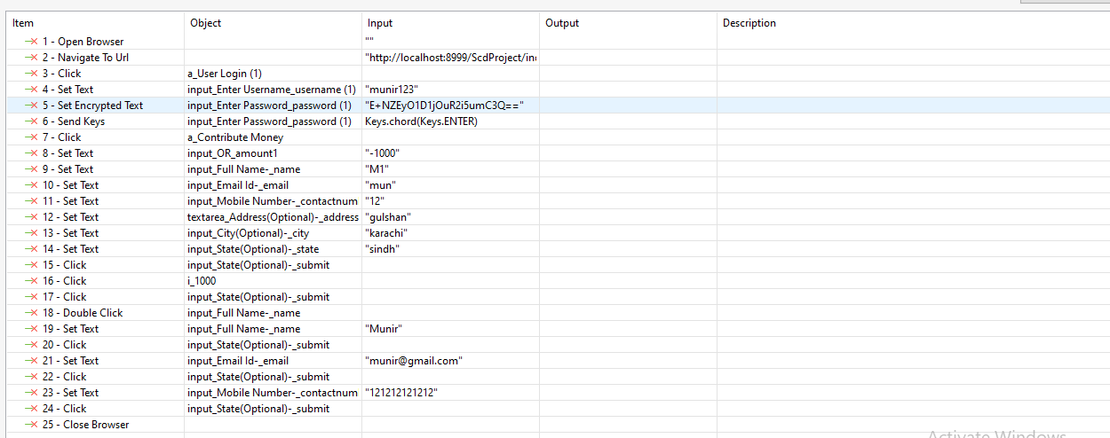

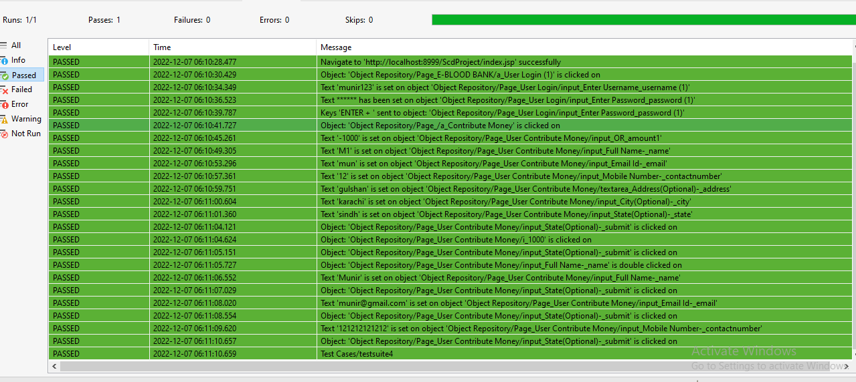

|  |  |
| --- | --- |
| Test Suite Name | New hospital added that can be viewed by user. |
| Test Suite usage | Once an admin logs in, the admin can create a new hospital. Then to verify, we will go to user mode and then view this hospital. |
| Test cases Included | 1. Test case 6. 2. Admin logout. 3. Test case 1. 4. Test case 5. |
| Test results | A new hospital can be viewed successfully. |

